**Procedure of Updating Document Based on EPC/End User Comments**

Assumption: EPC/end users were commenting the document using Acrobat (or similar software).

Objectives:-

1. To keep track all the changes.
2. To make sure all the comments have been gone through.

**Microsoft Word (Native File)**

1. Make sure that the changes from last revision (e.g. Rev. 2) are accepted before start amending the document. This can be done by clicking “Accept All Changes in Document” from “Accept” drop down menu, refer figure below. By clicking “Accept All Changes in Document”, all the changes which were done on last revision document (e.g. Rev 2) will get accepted and will not be shown again after accepted.

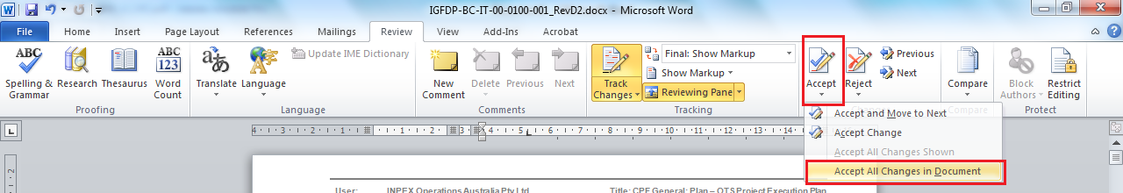

This is to avoid confusion on the amendment on this revision (e.g. Rev. 3) from last revision document (e.g. Rev. 2).

1. Make sure that “Track Changes” is selected before start amending the document using Microsoft Word, refer to diagram below.

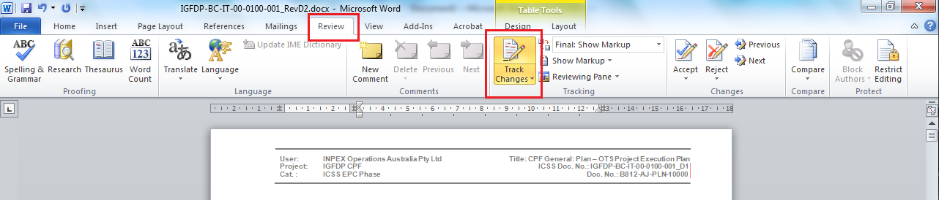

You may change from “Final: Shows Markup” to “Final”, especially when you want to make sure the document alignment and format before submission.

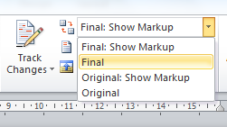

The differences between “Final: Shows Markup” and “Final” are shown below.

* “Final: Shows Markup” – all changes (insertions / deletions) will be shown on native file, refer to figure below.

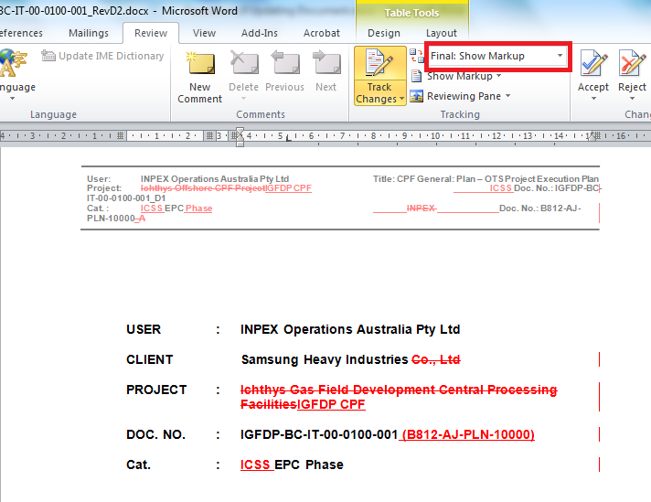

* “Final” – all changes will NOT be shown on native file, refer to figure below.

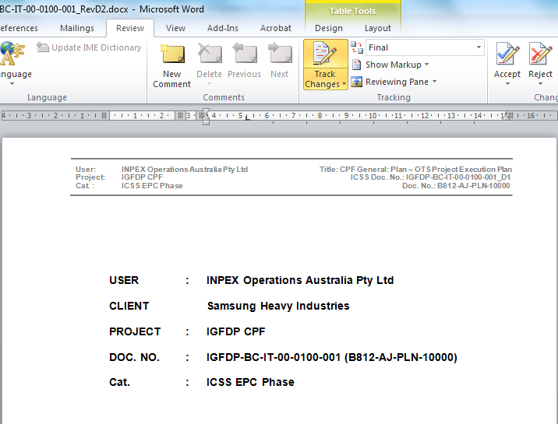

**Acrobat Professional (Commented Document from EPC/End User)**

1. Click on “COMMENT” as shown figure below (red box).



1. The list of comments is shown in figure below (red box).

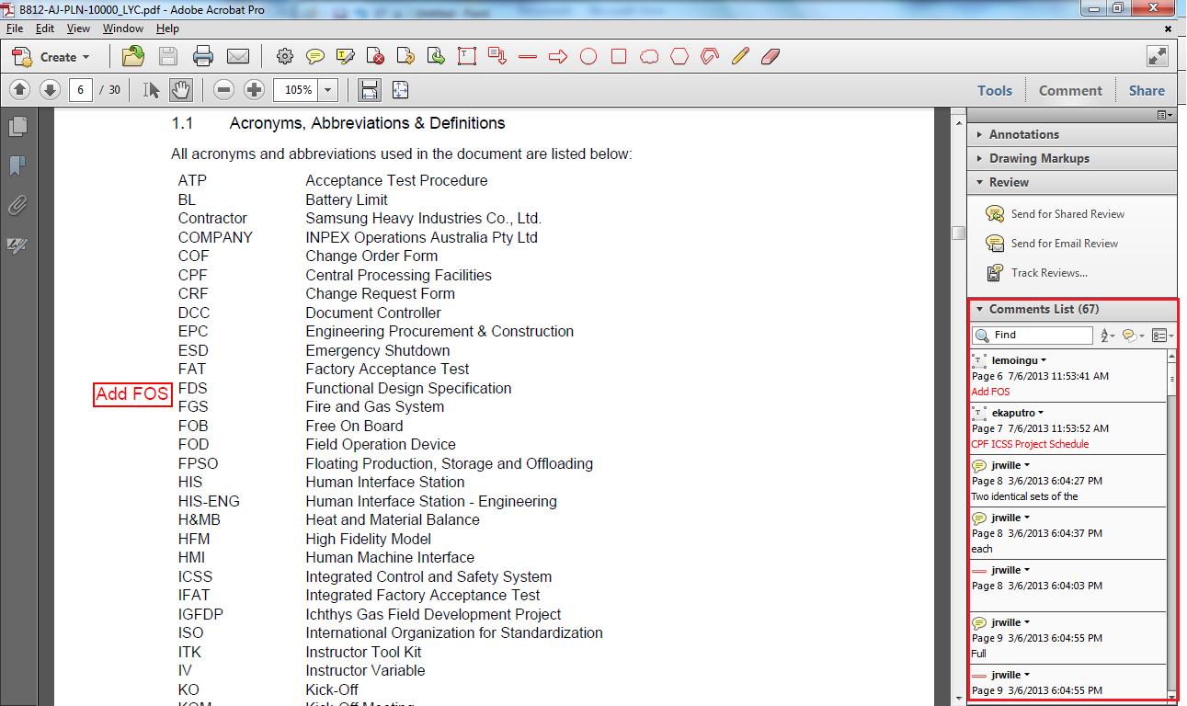

1. Click on comment from the Comments List, it will bring you to related page.
2. Update the document based on the selected comment.
3. Update the comment status once Step 4 is completed. Right click on the selected comment, select “Set Status” and select “Completed”.

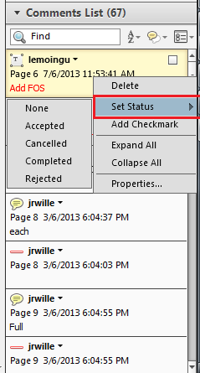

1. If the selected comment is not applicable or not necessary, you may reject the comment by selecting “Rejected” from “Set Status” drop down menu. Please provide the reason why the comment is rejected by using “Reply” (if available)

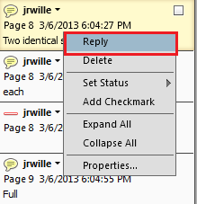

Or placing a note (reason of rejected the comment) next to selected comment on the document by clicking “Add sticky note” as shown below.



The status of the comment is shown in the Comment List, as below.

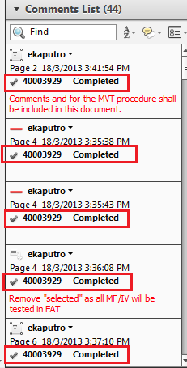

1. Repeat Step 3 – 6 for remaining comments.
2. After completed, save the document with new file name so that all the comments’ status are captured.